Church of Hope Annual Golf Classic
Hosted by Legacy Golf Club
Saturday, May 4th, 2019

Tournament Fee(s):
4-player Scramble Format
Registration
$100 individual
$400 foursomes

Includes greens fees, cart, gifts, catered lunch, beverages & snacks. Incredible raffle and
contest prizes!

Check-In:
7:00 – 8:00 a.m
Shot Gun Start:
8:00 a.m

Sponsorship

Hole Sponsor: $150
Hole sponsors receive a full color tee box sign
Corporate Sponsor $500
Corporate sponsor includes
A foursome and full color tee box sign.
SPONSORSHIP DEADLINE 04/23/2019
Please submit artwork or verbiage in high resolution format to: Aimee Case – aimee@airrific.com
Sponsored By:

Lee Brewer of
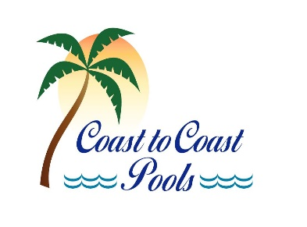
Featuring:
Prizes for 1st 2nd and 3rd place
Million Dollar Cash Shoot Out
Including a 7 night resort stay for golfer closet to the pin.
Hole in One Contest
Winner receives a Pebble Beach Golf Vacation or $10,000 cash
Putting Contest
Winner receives a 4 night/5 day Caribbean Cruise
Closest to the Pin and Long Drive Contest
Winners receive 2 VIP tickets to a professional sporting event.

Company Name:____________________________________________
Contact Person:_____________________________________________
Company Address:___________________________________________
Company Email:_____________________________________________
Phone #: ___________________________________________________

Registration

Return registration form along with check(s) made payable to Church of Hope please indicate golf on memo line.
Address to: Church of Hope c/o Chandler Groover 1560 Wendell Kent Rd. Sarasota Florida 34240 Re: Golf Tournament
Or hand deliver to Chandler Groover at Church of Hope. Registration must be submitted by 4/30/2019

Player 1 Name:___________________________________________________________

Player 2 Name:___________________________________________________________

Player 3 Name:___________________________________________________________

Player 4 Name:___________________________________________________________

Team Contact (name, email and phone number):_________________________
_________________________________________________________________
Amount enclosed $_________________________________________________

For more information contact:
Aimee Case 941-400-7352
aimee@airrific.com

or

Chandler Groover 941-210-2556
chandlergroover@gmail.com

